EXPERIMENT- 10
Student Name: Kanaboina Yashwanth UID: 23BCS10501
Branch: BE-CSE Section/Group: KRG-1A
Semester: 05 Date of Performance: 30/10/25
Subject Name:ADBMS Subject Code: 23CSP-333

- Aim: To perform CRUD operations and aggregation using MongoDB, a NoSQL document-based database.
- Objective:

Learn creation of databases and collections in MongoDB. Execute Insert, Read, Update, and Delete operations.
- Tools / Software

MongoDB

Mongo Shell
Sample Dataset: Car Dealership Data
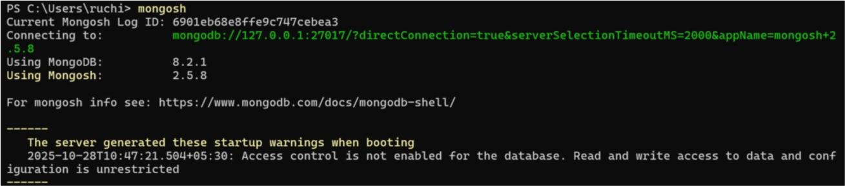
4

.Program

:


-- showdbs

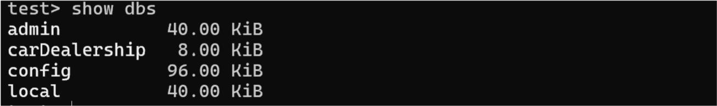

-- use car_dealership

INSERTION OPERATION:
db.createCollection("cars")
db.cars.insertMany([
{ maker: "Hyundai", model: "i20", fuel_type: "Petrol" },
{ maker: "Tata", model: "Nexon", fuel_type: "Diesel" },
{ maker: "Kia", model: "Seltos", fuel_type: "Petrol" },
{ maker: "Maruti", model: "Swift", fuel_type: "CNG" }
])

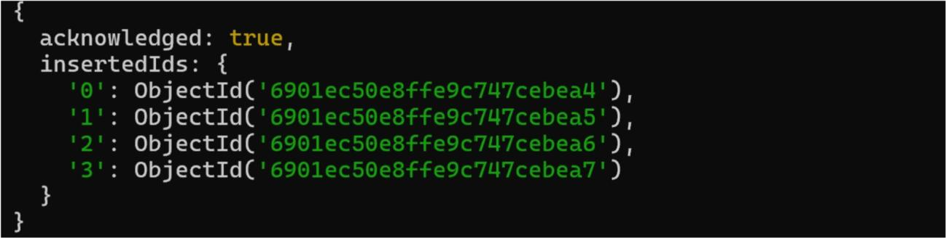

READOPERATION:
db.cars.find()
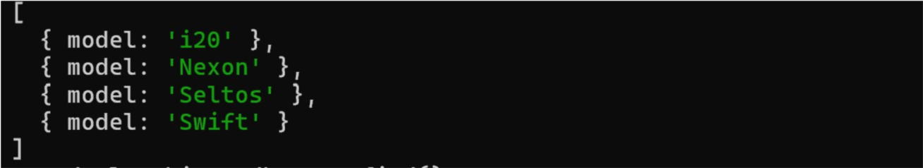
db.cars.find({fuel_type:"Petrol"})

db.cars.find({},{model:1,_id:0})

UPDATE OPERATION:
db.cars.updateOne({ model: "i20" }, { $set: { fuel_type: "Hybrid" } })
db.cars.updateMany({}, { $set: { color: "White" } })
db.cars.updateOne({ model: "Nexon" }, { $push: { features: "Sunroof" } })

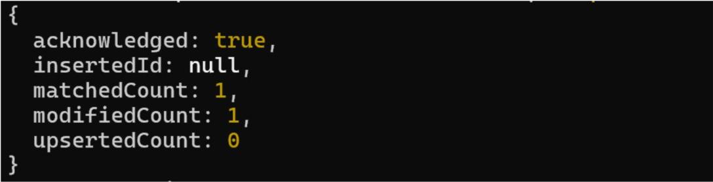
DELETEOPERATION:
db.cars.deleteOne({ model: "Swift" })

AGGREGATION:
db.cars.aggregate([{ $group: { _id: "$maker", totalCars: { $sum: 1 } } }])

